Week 7 & 8 Excercise
Lottery Numbers
Tejashri Bhilare
MS in Data Science, Bellevue University
DSC640 – Data Presentation and Visualization
Professor - Catie Williams
February, 2025

Data Story Telling : Evaluating the Randomness of Lottery Draws

Audience:
The primary audience for this analysis consists of internal analysts responsible for evaluating patterns and randomness in lottery draws.
These analysts have a strong understanding of statistical principles and data visualization techniques, enabling them to interpret complex visual data effectively.

Purpose:
The objective of this analysis is to assess whether the winning lottery numbers from Mega Millions, Powerball, and New York Pick 10 exhibit true randomness.
By leveraging statistical visualizations, we aim to identify any potential biases, trends, or anomalies in number selections. The insights from this analysis will inform recommendations for further statistical validation and potential regulatory scrutiny.

Medium:
The analysis is presented through an interactive Tableau dashboard, allowing analysts to explore the data dynamically. This medium is well-suited for internal analysts, as it facilitates in-depth exploration of lottery trends through filters, tooltips, and interactive elements.
Design Choices:
- Color: Distinct color schemes differentiate between Mega Millions, Powerball, and Pick 10 results to enhance clarity.
- Text: Minimal text with clear, concise labels to avoid clutter and maintain focus on data insights.
- Alignment: Well-structured dashboard layout with a logical flow from broad distributions to detailed number occurrences.
- Sizing & Spacing: Balanced use of white space to avoid overwhelming the viewer while maintaining data density.

Visualizations Used:
- Histogram – Displays the frequency distribution of winning numbers to evaluate uniformity.
- Scatterplot – Identifies potential number pairings that may appear together frequently.
- Density Plot – Analyzes concentration of specific numbers over time.
- Bubble Chart – Compares the frequency of different numbers across lottery types.
- Line Chart – Examines rolling trends of specific numbers over time.

Ethical Considerations:
- Data Integrity: The datasets were used without modification beyond necessary cleaning (e.g., date formatting, unpivoting columns).
- Transparency: All transformations and filters are clearly labeled in the dashboard to avoid misleading interpretations.
- Regulatory Compliance: No private or sensitive data was used; all datasets are publicly available.
- Potential Bias: Ensuring that visual interpretations do not mislead users into false conclusions about non-randomness without statistical validation.

Histogram : Luck or Pattern? Analyzing Lottery Number Frequency

- Purpose: Check if all numbers appear equally over time.

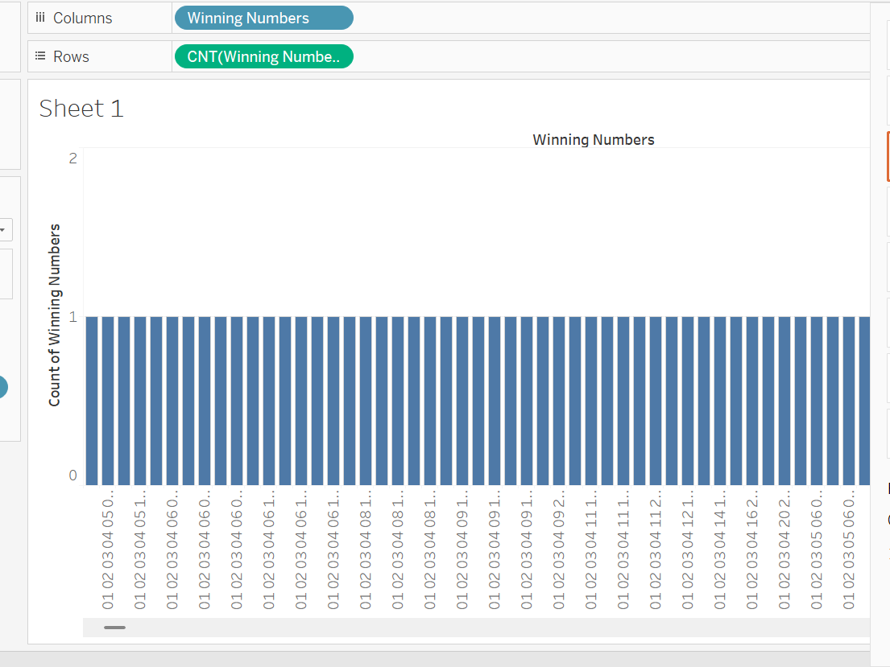

Density Plot (Number Trends Over Time)
"Hot Numbers Over Time: Are Some More Lucky?"
• Purpose: Analyze if certain numbers appear more frequently over time.
• 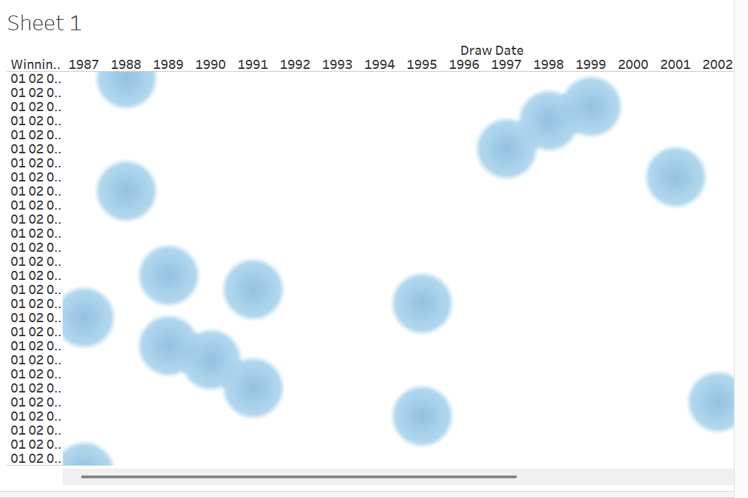

Bubble Chart (Number Frequency Comparison)

"Most Drawn Numbers: The Champions of Chance"
- Purpose: Compare the occurrence of each number in different games.

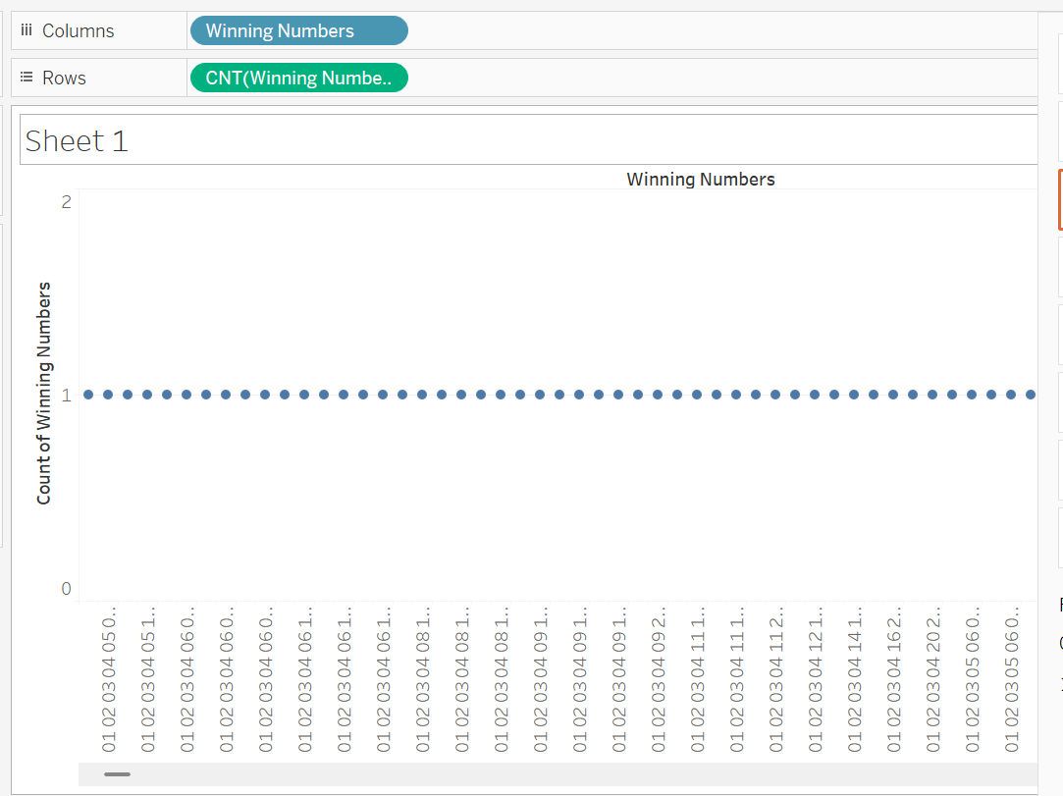

"Side-by-Side: Do Different Lotteries Follow the Same Trends?"

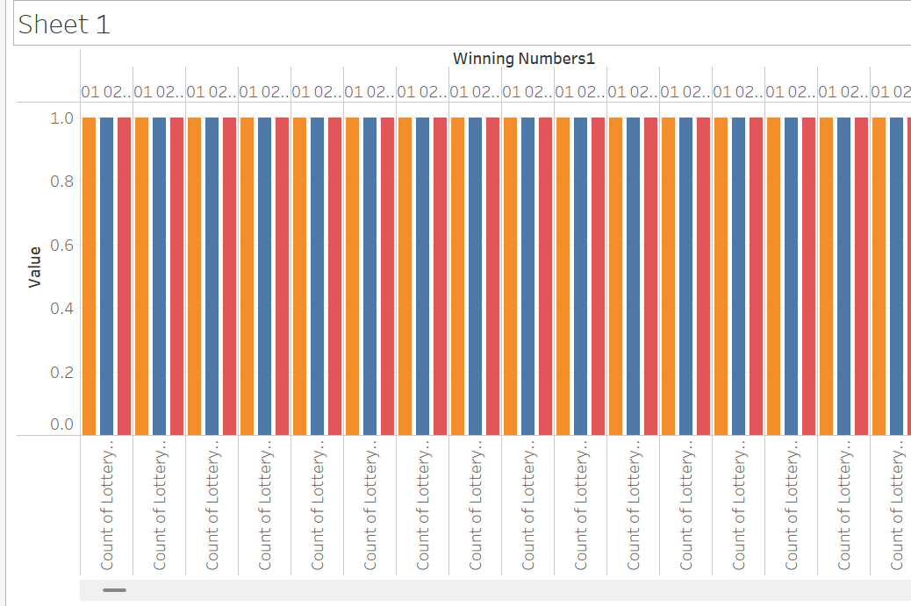

Line Chart (Rolling Frequency of a Specific Number)

"Number Trends Over Time: Rising Stars or Random Picks?"
Purpose: Track the historical frequency of a specific number.

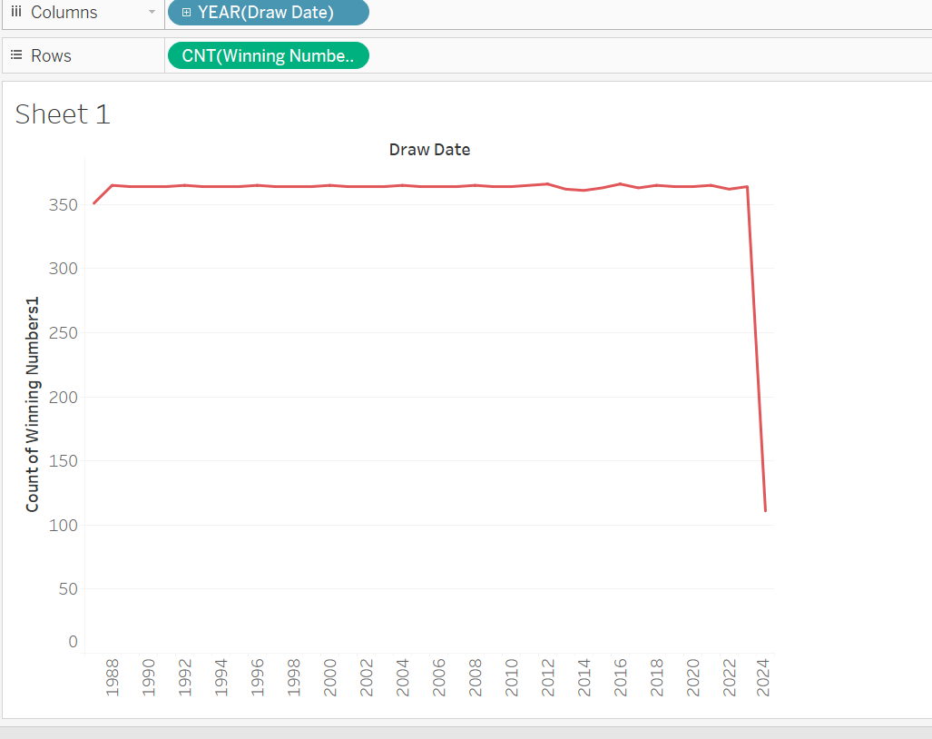

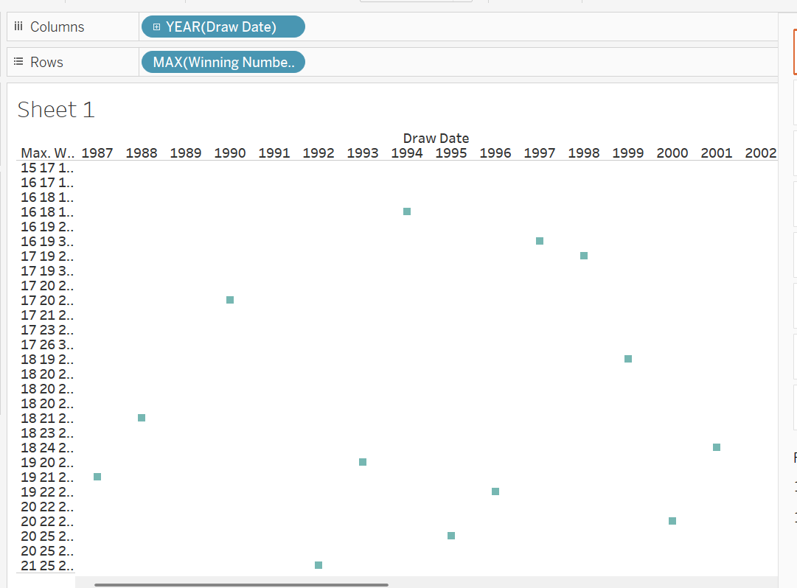

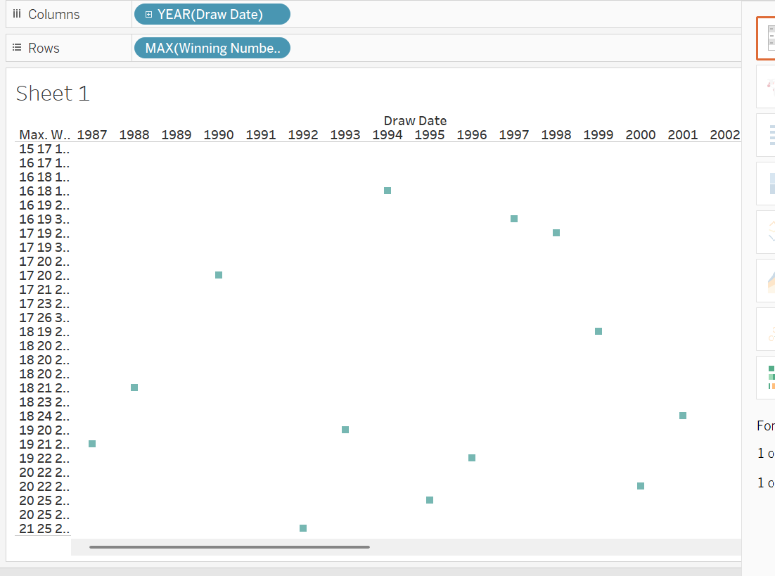

Conclusion & Call to Action:
This analysis provides a data-driven perspective on the randomness of lottery draws. While visualizations may indicate patterns, randomness should be further validated using statistical tests.
Internal analysts are encouraged to conduct deeper statistical tests, such as chi-square goodness-of-fit tests, to formally assess number distributions. If significant anomalies are detected, further regulatory review may be warranted.

